THE INSTITUTE  RCC Institute of Information Technology (RCCIIT) is an Engineering College affiliated to the West Bengal University of Technology and is approved by the All-India Council of Technical Education (AICTE).  It was setup in 1999 by Regional Computer center Calcutta, with active support from National Informatics Center (NIC), Govt. of India and Dept of Higher Education, Govt. of West Bengal.  RCC Institute of Information Technology, is now under RCC Institute Of Technology, an autonomous Society of Department of Higher Education, Govt. Of West Bengal.  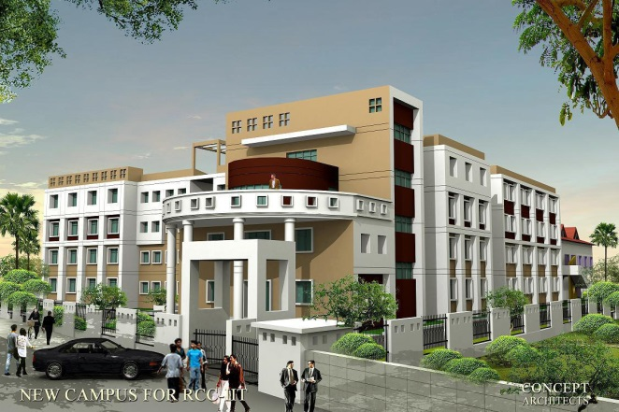  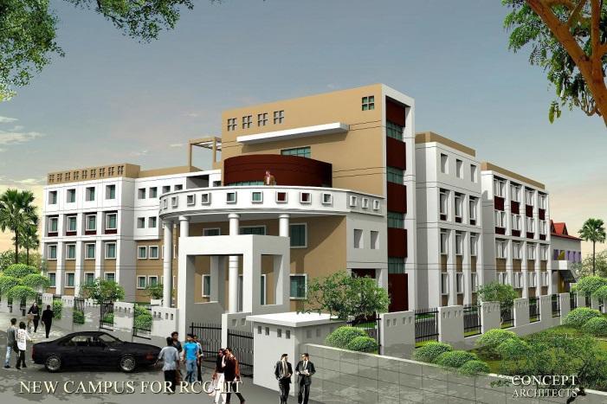  THE DEPARTMENT  The Department of Electrical Engineering (which is now accredited by National Board of Accreditation (NBA), New Delhi) started its journey in the year 2009 under RCCIIT and the first batch of students graduated in the year 2013. The department offers Electrical Engineering (EE) undergraduate program that augments the liberal education to undergraduates and imparts well understanding of the subject, Electrical Engineering and its different aspects built on a foundation of Science, Mathematics, Computation, Engineering and Technology. which is monitored through the Institutional Admission Committee following the guidelines of the Maulana Abul Kalam Azad University of Technology. The present intake of this department is 60. | 3 days Student Workshop  Organized by  Department of Electrical engineering  Date:  27th – 29th July, 2022  Timing  11 am – 1 pm  Lunch Break  2 – 4 pm |  | RCC Institute of Information Technology  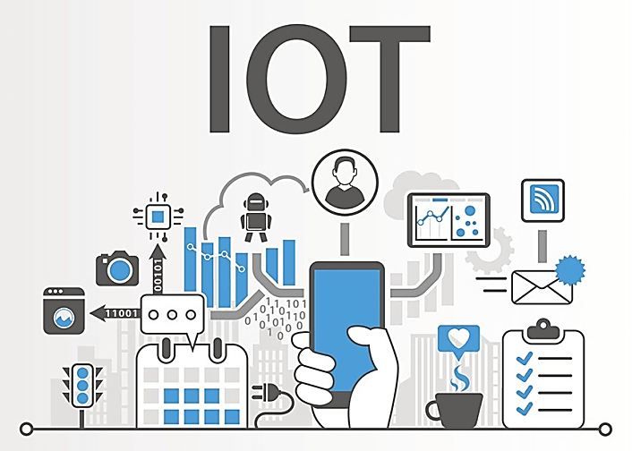  Department of Electrical Engineering  3 Days Hands- on Workshop to Bridge UG Curriculum Gap  on  “ Introduction of Recent Simulation Tool and its application in IOT ”
Convener
Mr. Budhaditya Biswas
Assistant Professor, Dept. of EE

Mr. Sarbojit Mukherjee
Assistant Professor, Dept. of EE

Venue
EE Dept. Computer Lab (N016)
Advisory Committee:  RCC Institute of Information Technology  Department of Electrical Engineering  Dr. Anirban Mukherjee, Principal  Dr. Abhishek Basu, FIC Academic  Dr. Shilpi Bhattacharya Deb, HOD & Asso. Prof.  Organizing Committee  Mr. Budhaditya Biswas (Asst. Prof., EE Dept)  Mr. Sarbojit Mukherjee (Asst. Prof., EE Dept)  Mr. Abir Sen, (Junior Assistant, EE Dept)  Registration  Participant should registration through below given link:  https://forms.gle/sj9p3vVGjC5RSAad6  Contact  Mobile: 9474477825  9433852385 |  | Aim of this workshop  The aim of this workshop is to provide the idea of different modern simulation tool, like MATLAB, Proteous, Keil and Arduino and some modern hardware like NodeMCU. Besides the aim is also explore the state-of- art technologies in the area of Internet of Things (IoT) through a series of lectures delivered by eminent persons working in this field and to provide some hands-on experiences in setting up IoT platform with open-source software.  Lectures  The Lecture sessions shall include the following:  - Introduction different modern simulation tool.  - Fundamentals of microcontroller  - Brief architecture of 8051 and GPIO  - Configuration of Node MCU  - Basic of IoT  Hands on  - Simulation on MATLAB programing.  - Build model in Simulink.  - Interfacing of LED, Relay, Keypad  - Blynk 2.0 with Node MCU  - Blynk Web server and Mobile dashboard  - Google assistant based IoT device control

